|  |  |  |  |
| --- | --- | --- | --- |
| Interface PCBA High Level Design Specification | | | |
| PM1 Pachymeter Automated System Level Test Platform | | | |
|  | Prepared for:  **Occuity Ltd**  **7th March 2021** |  |  |

Table of Contents

2 INTRODUCTION 5

2.1 Purpose 5

2.2 Scope 5

2.3 Document Overview 5

3 Interface PCBA SOLUTION 6

3.1 Overview 6

3.2 High Level design 7

3.2.1 Overview 7

3.2.2 Connector Pinouts 7

3.2.2.1 PM1 Pachymeter to Interface PCBA 7

3.2.2.1.1 Display Connector 7

3.2.2.1.2 Debug Connector 8

3.2.2.1.3 Laser Board Connector 9

3.2.2.1.4 Encoder Connector 9

3.2.2.1.5 USB Pass-Through Connector 10

3.2.2.1.6 DUT Power Connector 10

3.2.2.2 Test Platform to Interface PCBA 10

3.2.2.2.1 Interface PCBA Power Connector 10

3.2.2.2.2 Total Phase Aardvark Connector 11

3.2.2.2.3 USB FT4232H Mini Module 11

3.2.2.2.4 USB FT232H Breakout 11

3.2.2.2.5 NI USB-6363 11

3.2.2.2.6 DUT USB Pass-Through 14

3.2.2.2.7 DUT Power Connector 14

3.2.3 Signal Routing and Conditioning 14

3.2.3.1 Display Connector 14

3.2.3.1.1 Touch Panel Simulation 14

3.2.3.1.2 Display Pass-Through 15

3.2.3.2 Debug Connector 15

3.2.3.3 Laser Board Connector 15

3.2.3.3.1 LON / LPON Simulation 15

3.2.3.3.2 Analogue Input Signal Simulation 15

3.2.3.4 Encoder Connector 15

3.2.3.4.1 Detection of Analogue H-Bridge Drive Activity 15

3.2.3.4.2 Playback of Encoder Signals 16

Disclaimers

The information contained in this document is for information purposes only and is subject to change without prior notice. While LeoTel Software Systems Limited endeavours to provide the updated document to all project parties, the user is advised to check that they are using the latest version of the document.

LeoTel Software Systems Limited disclaims all warranties, express or limited, including, but not limited, to the implied warranties of merchantability and fitness for a particular purpose, except as provided for in a separate software licence agreement.

trademarks

All trademarks recognised.

change history

|  |  |  |  |
| --- | --- | --- | --- |
| Version | Author | Date of Change | Description |
| 0.1 | James Bridson | 29-Oct-2021 | Initial version. |
| 0.2 | James Bridson | 10-Nov-2021 | Revision for Occuity and LeoTel joint review. |
| 0.3 | James Bridson | 18-Nov-2021 | Updated following first review. |
| 0.4 | James Bridson | 22-Dec-2021 | Incorporated comments from final LeoTel & Occuity review. |
| 0.5 | James Bridson | 07-Mar-2022 | Updated following PCBA B1 integration. |

document references

|  |  |  |  |  |  |
| --- | --- | --- | --- | --- | --- |
| Ref. | Document Id | Title | Author | Issue | Date |
| 1 | P1-SOF-SIS-01 | Software Interface Specification | Occuity | 2 | 21-Jun-2021 |
| 2 | P1-SOF-ASV-01 | Automated System- and Subsystem-Level Software Verification – Proposal | Occuity | Draft 1 | 18-Jun-2021 |
| 3 | LSSL/20210723/01 | Development Proposal | LSSL | 1.1 | 23-Sep-2021 |

Applicable Standards

|  |  |
| --- | --- |
| Term | Description |
| ISO 13485 | Medical devices – quality management systems – Requirements for regulatory purposes |
| IEC 62304 | Medical device software – software lifecycle processes |
| ISO 14971 | Medical devices – Application of risk management to medical devices |
| ISO/IEC 12207 | Systems and software engineering – Software life cycle processes |

GLOSSARY & ACRONYMS

|  |  |
| --- | --- |
| Term | Description |
| AI | Analogue Input |
| AO | Analogue Output |
| APFI | Analogue Programmable Function Interface |
| CC | Constant Current |
| COTS | Commercial Off-The-Shelf |
| DI | Digital Input |
| DIO | Digital Input / Output |
| DNC | Do Not Connect |
| DNF | Do Not Fit |
| DO | Digital Output |
| DUT | Device Under Test |
| FFC | Flexible Flat Cable |
| FPC | Flexible Printed Circuit |
| GPIO | General Purpose Input / Output |
| IEC | International Electrotechnical Commission |
| ISO | International Organization for Standardization |
| LDA PCB | Laser Driver and Amplifier Printed Circuit Board |
| LSC PESS | Linear Scanner Controller Programmable Electronic Sub-System |
| OTS | Off-The-Shelf |
| Pachymeter | A scientific instrument used to measure the thickness of the cornea using laser, light waves or ultrasound. |
| PCB | Printed Circuit Board |
| PCBA | Printed Circuit Board Assembly |
| PDA PESS | Pachymeter Data Acquisition Programmable Electronic Sub-System |
| PE PESS | Pachymeter Environmental Programmable Electronic Sub-System |
| PFI | Programmable Function Interface |
| PI PESS | Pachymeter Interface Programmable Electronic Sub-System |
| TBC | To Be Confirmed |
| UUT | Unit Under Test |
| WP*n* | Work Package *n* |

# INTRODUCTION

This specification documents the high-level design for the Occuity interface printed circuit board assembly (PCBA). The PCBA will act as an interface between the PM1 Pachymeter under test and the test platform providing connectivity of the input/output test signals and any associated signal conditioning where required. The PCBA will also provide some general purpose digital input/output, for future control/monitoring needs, and pass-thru of other useful signals e.g. to the LCD.

## Purpose

This document is primarily intended to be used:

* As a means of communication between and LeoTel Software Systems Limited (LSSL) to clarify the high-level design of the Interface PCBA, and to ensure that both parties have the same understanding of the design; and
* By hardware and software engineers during the project, in particular when constructing the test platform.

## Scope

This document covers the hardware signals, interfaces, interconnections and any signal conditioning required on the Interface PCBA in order to meet the requirements documented in reference [3].

## Document Overview

The remainder of this document is organised into sections as follows:

Section 3 documents the Interface PCBA High Level Design

# Interface PCBA SOLUTION

## Overview

The logical components in the PM1 Pachymeter Automated System Level Test Platform are summarised in the following diagram:



This document covers the hardware signals, interfaces, interconnections and any signal conditioning required on the block labelled ‘System-Level Test Platform to Test Bed Interface’ in order to provide a convenient interface between the PM1 Pachymeter Automated System Level Test Platform and the PM1 Pachymeter under test.

## High Level design

### Overview

The following block diagram illustrates the connectivity that will be provided by the Interface PCBA between the PM1 Pachymeter Automated System Level Test Platform and the PM1 Pachymeter device under test (DUT).

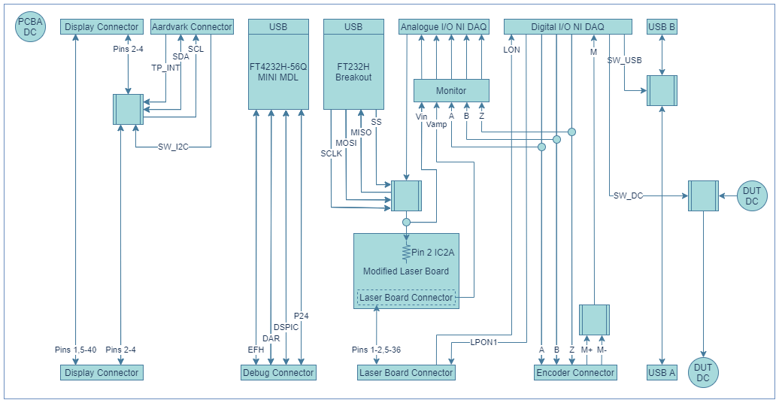

### Connector Pinouts

#### PM1 Pachymeter to Interface PCBA

##### Display Connector

The PM1 Pachymeter main board display connector (X1) will connect to the interface PCBA via an FFC terminated at a MOLEX 54104-4033 FFC-to-board 0.50mm 40 circuit connector.

The FFC carries the LCD display and touch panel signals between the PM1 Pachymeter main board and the interface PCBA.

| Pin | Signal | Level | Direction | Notes |
| --- | --- | --- | --- | --- |
| X1-1 | ~TP_RESET | 0V/+3V3 | Output | TP Reset (active low) |
| X1-2 | TP_INT | 0V/+3V3 | Input | TP Interrupt (active high) |
| X1-3 | SDA3 | 0V/+3V3 | Open Drain | I2C Serial Data |
| X1-4 | SCL3 | 0V/+3V3 | Open Drain | I2C Serial Clock |
| X1-5 | +3V3 | +3V3 | Power | Power |
| X1-6 | GND | GND | Ground | Signal Ground |
| X1-7 | N/C |  |  | N/C |
| X1-8 | N/C |  |  | N/C |
| X1-9 to X1-19 | GD3 to GD15 | 0V/+3V3 | Output | LCD Data |
| X1-20 | GND | GND | Ground | Signal Ground |
| X1-21 to X1-25 | GD19 to GD23 | 0V/+3V3 | Output | LCD Data |
| X1-26 | GND | GND | Ground | Signal Ground |
| X1-27 to X1-36 | DISPLAY_* | 0V/+3V3 | Output | LCD Control |
| X1-37 | +3V3 | +3V3 | Power | LCD Power |
| X1-38 | GND | GND | Ground | Signal Ground |
| X1-39 | LCD_BACKLIGHT | 20mA (CC) | Power | LCD Backlight Anode |
| X1-40 | GND | GND | Ground | LCD Backlight Cathode |

The interface PCBA will support a pass-through facility to a display assembly via an FFC terminated at a MOLEX 54104-4033 FFC-to-board 0.50mm 40 circuit connector.

The FFC carries the pass-through LCD display and touch panel signals between the PM1 Pachymeter main board and the interface PCBA.

| Pin | Signal | Level | Direction | Pass-Through | Notes |
| --- | --- | --- | --- | --- | --- |
| 1 | ~RST | 0V/+3V3 | Output | Direct | TP Reset |
| 2 | IRQ | 0V/+3V3 | Input | Switched | TP Interrupt |
| 3 | SDA | 0V/+3V3 | Open Drain | Switched | I2C Serial Data |
| 4 | SCL | 0V/+3V3 | Open Drain | Switched | I2C Serial Clock |
| 5 | +3V3 | +3V3 | Power | Direct | Power |
| 6 | GND | GND | Ground | Direct | Signal Ground |
| 7 | N/C |  |  | Direct | N/C |
| 8 | N/C |  |  | Direct | N/C |
| 9 to 19 | GD3 to GD15 | 0V/+3V3 | Output | Direct | LCD Data |
| 20 | GND | GND | Ground | Direct | Signal Ground |
| 21 to 25 | GD19 to GD23 | 0V/+3V3 | Output | Direct | LCD Data |
| 26 | GND | GND | Ground | Direct | Signal Ground |
| 27 to 36 | DISPLAY_* | 0V/+3V3 | Output | Direct | LCD Control |
| 37 | +3V3 | +3V3 | Power | Direct | LCD Power |
| 38 | GND | GND | Ground | Direct | Signal Ground |
| 39 | LCD_BACKLIGHT | 20mA (CC) | Power | Direct | LCD Backlight Anode |
| 40 | GND | GND | Ground | Direct | LCD Backlight Cathode |

##### Debug Connector

The PM1 Pachymeter main board debug connector (X6) will connect to the interface PCBA via a PicoBlade Male-to-PicoBlade Male Off-the-Shelf (OTS) Cable Assembly terminated at a MOLEX 53398-0971 PicoBlade PCB Header 1.25mm 9 circuit connector.

The cable assembly carries the microprocessor serial debug signals between the PM1 Pachymeter main board and the interface PCBA.

| Pin | Signal | Level | Direction | Notes |
| --- | --- | --- | --- | --- |
| X6-1 | GND | GND | Ground | Signal Ground |
| X6-2 | EFH_DBG_RX | 0V/+3V3 | Input | Serial Receive |
| X6-3 | EFH_DBG_TX | 0V/+3V3 | Output | Serial Transmit |
| X6-4 | DAR_DBG_RX | 0V/+3V3 | Input | Serial Receive |
| X6-5 | DAR_DBG_TX | 0V/+3V3 | Output | Serial Transmit |
| X6-6 | DSPIC_DBG_RX | 0V/+3V3 | Input | Serial Receive |
| X6-7 | DSPIC_DBG_TX | 0V/+3V3 | Output | Serial Transmit |
| X6-8 | P24_DBG_RX | 0V/+3V3 | Input | Serial Receive |
| X6-9 | P24_DBG_TX | 0V/+3V3 | Output | Serial Transmit |

##### Laser Board Connector

The PM1 Pachymeter main board laser connector (J1) will connect to the Interface PCBA via one of two SAMTEC CLM-118-02-F-D low profile dual wipe 1.00mm board-to-board connectors on either side of the Interface PCBA.

| Pin | Signal | Level | Direction | Pass-Through | Notes |
| --- | --- | --- | --- | --- | --- |
| J1-1 to J1-2 | - | - | - | Direct |  |
| J1-3 | LON | 0V/+3V3 | Output | Direct | Laser on also connected to an NI digital input. |
| J1-4 | LPON1 | 0V/+5V | Input | N/C | Laser on check connected to an NI digital output. |
| J1-5 to J1-9, J1-11 to J1-12, J1-16, J1-20, J1-24, J1-28 to J1-32 | - | - | - | Direct |  |
| J1-10, J1-13 to J1-15, J1-17 to J1-19, J1-21 to J1-23, J1-25 to J1-27, J1-33 to J1-36 | GND | GND | Ground | Direct | Common Analogue and Signal Ground |

These board-to-board connectors carries the laser board assembly signals between the PM1 Pachymeter main board and the Interface PCBA and will be mounted according to the following layout and dimensions:

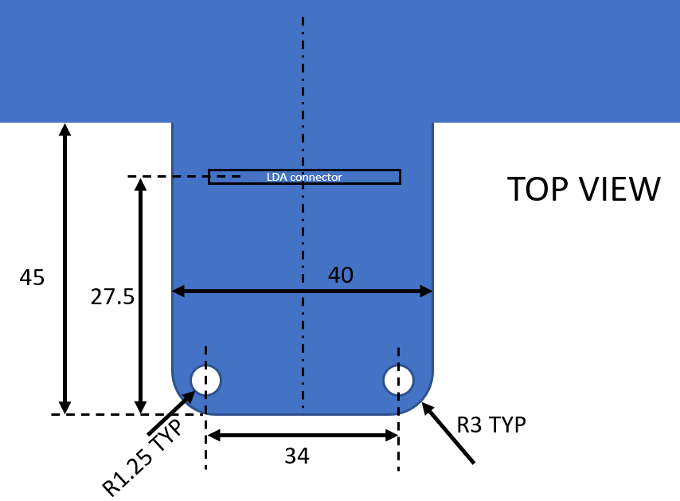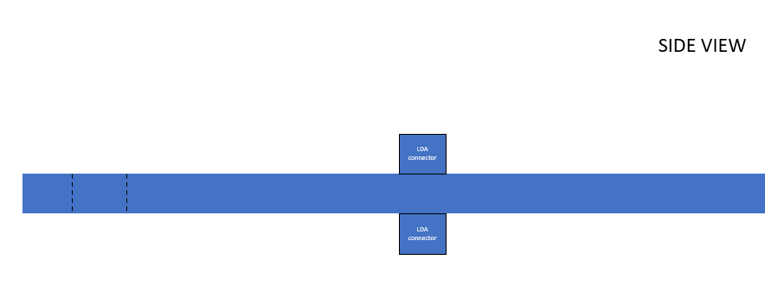

A modified PM1 Pachymeter laser board will be mounted on the Interface PCBA via a SAMTEC FTMH-118-03-F-DV surface mount micro terminal strip board-to-board connector.

The modification will allow an analogue signal to be fed in to pin 2 IC2A via a 5.1M resistor.

##### Encoder Connector

The PM1 Pachymeter main board encoder connector (X7) will connect to the Interface PCBA via an FFC terminated at a MOLEX 54550-1033 FFC-to-board 0.50mm 10 circuit connector.

| Pin | Signal | Level | Direction | Notes |
| --- | --- | --- | --- | --- |
| X7-1 | +5V5 | +5V5 | Power | Power |
| X7-2 | GND | GND | Ground | Ground |
| X7-3 | M+ | 0V/+5V5 | Output | Analogue H-Bridge Drive Output |
| X7-4 | M- | 0V/+5V5 | Output | Analogue H-Bridge Drive Output |
| X7-5 | A | 0V/+5V | Input | Encoder A Channel |
| X7-6 | B | 0V/+5V | Input | Encoder B Channel |
| X7-7 | ~A | 0V/+5V | Input | N/C on encoder board |
| X7-8 | ~B | 0V/+5V | Input | N/C on encoder board |
| X7-9 | Z | 0V/+5V | Input | Encoder Z Channel |
| X7-10 | LS | 0V/+5V | Open Drain | Pull-up on the encoder board (S1 DNF) |

This FFC carries the M+/M- analogue H-bridge drive and A, B & Z encoder signals between the PM1 Pachymeter main board and the Interface PCBA.

##### USB Pass-Through Connector

The PM1 Pachymeter main board USB connector (CN2) (or development board micro USB CN2 connector) will connect to the Interface PCBA via a standard USB-A connector (and a suitable cable). The interface board will facilitate pass through (via a switch) to a micro-USB-B connector that will connect to a PC using a suitable USB cable (e.g. micro-USB-B to USB-A or micro-USB-B to USB-C). The switch should facilitate switching both power and data on and off.

| Pin | Signal | Level | Direction | Notes |
| --- | --- | --- | --- | --- |
| 1 | VCC | +5V | Power | USB A Power |
| 2 | D- | 0V/+5V | Ground | USB A Data - |
| 3 | D+ | 0V/+5V | Output | USB A Data + |
| 4 | GND | GND | Ground | USB A Ground |

##### DUT Power Connector

A 2 way screw terminal connector will be provided to carry a switched 7.5VDC unregulated supply between the Interface PCBA and the PM1 Pachymeter development board. This allows connection of a DC barrel plug terminated cable or other suitable powering connector.

| Screw Terminal | Signal | Level | Direction | Notes |
| --- | --- | --- | --- | --- |
| 1 | 0/+7V5 | 0/+7V5 | Power | Power |
| 2 | GND | GND | Ground | Ground |

#### Test Platform to Interface PCBA

##### Interface PCBA Power Connector

The Interface PCBA will be powered from a 7.5VDC external power supply connected via a barrel connector from a wall-wart supply. This will be used to derive any other voltages needed on board.

| Pin | Signal | Level | Direction | Notes |
| --- | --- | --- | --- | --- |
| 1 | 0/+7.5V | 0/+7.5V | Power | Power |
| 2 | GND | GND | Ground | Ground |

##### Total Phase Aardvark Connector

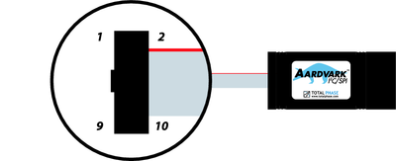

The Total Phase Aardvark I2C/SPI Host adapter connects to the Windows PC controlling the automatic test activity via a USB 1.1 Full-Speed (12 Mbit/s) interface.

The host adapter has a standard 10-wire 1.25 mm (0.050”) pitch cable terminated with a standard IDC 2.54 mm (0.100”) pitch IDC type connector.

The I/O signals used by the PM1 Pachymeter Automated System Level Test Platform will be connected through to the Interface PCBA via a standard IDC 2.54 mm (0.100”) pitch IDC type connectors and keyed boxed header.

| Pin | Signal | Level | Direction | Notes |
| --- | --- | --- | --- | --- |
| 1 | SCL | 0V/+3V3 | Open Drain | I2C Serial Clock with 2K2 pull-up resistor |
| 2 | GND | 0V | Ground | Signal Ground |
| 3 | SDA | 0V/+3V3 | Open Drain | I2C Serial Data with 2K2 pull-up resistor |
| 4 | N/C |  |  | DNC |
| 5 | GPIO5 | 0V/+3V3 | Output | Touch Panel IRQ (active low) |
| 6 | N/C |  |  | DNC |
| 7 | GPIO7 | 0V/+3V3 | Output | Touch Panel Switching Control |
| 8 | GPIO8 | 0V/+3V3 |  | Spare |
| 9 | GPIO9 | 0V/+3V3 |  | Spare |
| 10 | GND | 0V |  | Signal Ground |

##### USB FT4232H Mini Module

The Interface PCBA will utilise an FTDI FT4232H mini module to provide a USB connection from a test PC to the microprocessor debug ports.

##### USB FT232H Breakout

The Interface PCBA will utilise an Adafruit FT232H breakout board to provide a USB connection from a test PC to drive SPI and GPIO interfaces for control of the input circuitry to pin 2 IC2A on the modified laser board (photodiode simulation).

##### NI USB-6363

The NI USB-6363 connects to the Windows PC controlling the automatic test activity via a USB 2.0 Hi-Speed (480 Mbit/s) interface.

The NI USB-6363 has 128 screw terminals for termination of I/O connections. The screw terminals are designed to accept wiring from 0.2047 mm2 to 1.3087 mm2 (16 AWG to 24 AWG).

###### Analogue

The NI USB-6363 can provide up to 32 single ended or 16 differential AI channels and up to 4 AO channels.

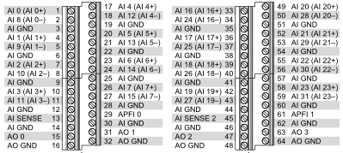

Analogue Output

AO channel 0 will be connected through to the Interface PCBA via coax cable onto a 2 way screw terminal connector for onward processing on the Interface PCBA.

| Screw Terminal | Signal | Level | Direction | Notes |
| --- | --- | --- | --- | --- |
| 15 | AO 0 | +/-5V | Output | Modified Laser Board - Photodiode Simulation |
| 16 | AO GND | AO GND | Ground |

Channel 0 will be used to interface to the modified laser board to drive the photodiode simulation.

Analog Input

AI channel 0 through 7 configured as differential channels will be connected through to the Interface PCBA via shielded cable onto a 16 way 2.54mm pitch shrouded post header.

These channels will be used for monitoring purposes during integration and testing of the automated test platform. All monitoring lines shall be routed with jumper links located close to the source of the signal to allow removing any impact of the sensing line on the signals.

| Pin | Signal | Level | Direction | Notes |
| --- | --- | --- | --- | --- |
| 1 | AI 0+ | +/-100mV to +/-10V | Input | Injected Signal (before 5.1M resistor) |
| 2 | AI 0- | GND |  |  |
| 3 | AI 1+ | +/-100mV to +/-10V | Input | Laser Board Vamp |
| 4 | AI 1- | GND |  |  |
| 5 | AI 2+ | +/-100mV to +/-10V | Input | Encoder M+ |
| 6 | AI 2- | GND |  |  |
| 7 | AI 3+ | +/-100mV to +/-10V | Input | Encoder M- |
| 8 | AI 3- | GND |  |  |
| 9 | AI 4+ | +/-100mV to +/-10V | Input | Encoder A |
| 10 | AI 4- | GND |  |  |
| 11 | AI 5+ | +/-100mV to +/-10V | Input | Encoder B |
| 12 | AI 5- | GND |  |  |
| 13 | AI 6+ | +/-100mV to +/-10V | Input | Encoder Z |
| 14 | AI 6- | GND |  |  |
| 15 | AI 7+ | +/-100mV to +/-10V | Input | Spare (routed to spare IDC header) |
| 16 | AI 7- | GND |  |  |

###### Digital

The NI USB-6363 can provide up to 48 DIO pins 16 of which are programmable PFI lines that can be used not only as normal static digital input/output pins but also as timing input/output signals for AI/AO/DI/DO or counter/timer functions.

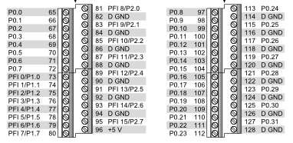

Digital Input/Output

DIO pins P0.0 - P0.3, P1.0 – P1.3 and P2.0 – P2.3 will be connected through to the Interface PCBA via a ribbon cable onto a 24 way 2.54mm pitch shrouded post header.

| Pin | Signal | Level | Direction | Notes |
| --- | --- | --- | --- | --- |
| 1 | P0.0 | 0V/+5V | Output | Encoder Board Connector – Encoder A Channel |
| 2 | D GND | GND |  | Signal Ground |
| 3 | P0.1 | 0V/+5V | Output | Encoder Board Connector – Encoder B Channel |
| 4 | D GND | GND |  | Signal Ground |
| 5 | P0.2 | 0V/+5V | Output | Encoder Board Connector – Encoder Z Channel |
| 6 | D GND | GND |  | Signal Ground |
| 7 | P0.3 | 0V/+5V | Output | Spare |
| 8 | D GND | GND |  | Signal Ground |
| 9 | P1.0 | 0V/+5V | Output | Laser Board Connector - LPON1 |
| 10 | D GND | GND |  | Signal Ground |
| 11 | P1.1 | 0V/+5V | Output | DUT DC Power Switching Control |
| 12 | D GND | GND |  | Signal Ground |
| 13 | P1.2 | 0V/+5V | Output | USB Pass-Through Switching Control |
| 14 | D GND | GND |  | Signal Ground |
| 15 | P1.3 | 0V/+5V | Output | Spare (routed to spare IDC header) |
| 16 | D GND | D GND |  | Signal Ground |
| 17 | P0.4 | 0V/+5V | Input | Laser Board Connector - LON |
| 18 | D GND | D GND |  | Signal Ground |
| 19 | P0.5 | 0V/+5V | Input | Encoder Board Connector – H-Bridge Drive (M) |
| 20 | D GND | D GND |  | Signal Ground |
| 21 | P0.6 | 0V/+5V | Input | Spare (routed to spare IDC header) |
| 22 | D GND | D GND |  | Signal Ground |
| 23 | P0.7 | 0V/+5V | Input | Spare (routed to spare IDC header) |
| 24 | D GND | D GND |  | Signal Ground |

##### DUT USB Pass-Through

The Interface PCBA will have a USB Micro-B connection for connection to a PC. All USB signals will be switchable under DIO software control so as to connect or disconnect through to the pass-through USB A connector that may be connected to the DUT via a USB A to USB C cable.

##### DUT Power Connector

The Interface PCBA will accept input from a +7.5VDC external power supply connected via a barrel connector from a wall-wart supply. This will be used to supply the switched screw terminal power output to the PM1 Pachymeter development board.

| Pin | Signal | Level | Direction | Notes |
| --- | --- | --- | --- | --- |
| 1 | 0/+7.5V | 0/+7.5V | Power | Power |
| 2 | GND | GND | Ground | Ground |

### Signal Routing and Conditioning

#### Display Connector

##### Touch Panel Simulation

The TP_INT, SDA3 and SCL3 touch panel signals will be switchable under DIO software control via the Total Phase Aardvark SPI/I2C Host Adapter configured to run in I2C and GPIO mode.

When automated testing is inactive these signals will be connected to the pass-through display connector on the Interface PCBA allowing normal LCD and touch screen behaviour.

When automated testing is active:

* TP_INT will be connected to a Total Phase Aardvark I2C/SPI Host Adapter GPIO pin allowing software control of the interrupt signal being fed to the PM1 Pachymeter main board. Both signals are +3V3 compatible so no further signal conditioning is required.
* SDA3 and SCL3 will be connected to the Total Phase Aardvark I2C/SPI Host Adapter allowing simulation of the I2C slave operation of the I2C touch controller. The host adapter and the PIC driving the display are +3V3 compatible and pull-up resistors for the I2C signals are provided within the host adapter so no further signal conditioning on the I2C clock and data signals is required.

##### Display Pass-Through

All signals coming from the PM1 Pachymeter main board display connector (X1), other than TP_INT, SDA3 and SCL3 will be connected directly to another MOLEX 54104-4033 FFC-to-board 0.50mm 40 circuit connector for pass-through connection to a display assembly via an FFC.

TP_INT, SDA3 and SCL3 touch panel signals will be switchable under software control between pass-through (default) and touch simulation modes.

#### Debug Connector

The four microprocessor serial debug connections will be connected to the digital inputs on the FT4232H mini module. The connections will be routed via 0R resistors.

#### Laser Board Connector

##### LON / LPON Simulation

The PM1 Pachymeter main board LON laser on command signal will be routed to a NI USB-6363 DI/PFI pin to allow software detection of the laser on command from the main board. It will also be routed to the modified laser board connector. The LON signal is 0V/+3V3 and is sufficient to drive the NI USB-6363 DI to a logic high.

An NI USB-6363 DO pin will be routed to the PM1 Pachymeter main board LPON1 laser on check signal to allow the simulation to confirm that the laser is on. The PIC32MZ102 is +5V input tolerant so this level does not need conversion but the connection will be carried via a simple voltage divider fitted with 0R and DNF resistors.

The actual LPON1 signal coming from the modified laser board connector remains not connected/unused.

All other pins on the laser board connectors are routed straight through.

##### Analogue Input Signal Simulation

The photodiode connection requires suitable level conversion / amplification and a software adjustable bias to be managed under software control. The control will be affected from the PC via the USB to SPI/GPIO breakout board.

The conditioned signal will be carried via a coaxial connection to the 5.1M resistor connected to pin 2 of IC2A on the modified laser board.

#### Encoder Connector

##### Detection of Analogue H-Bridge Drive Activity

The M+ and M- Analogue H-Bridge drive signals will be connected through a summing amplifier through a low pass RC filter and fed into a comparator along with an adjustable threshold set by a manual potentiometer. The output from the comparator will then be used to directly drive a NI USB-6363 DI/PFI pin. This will allow detection of, and triggering on, Analogue H-Bridge drive activity during automated testing.

##### Playback of Encoder Signals

The encoder A, B and Z channel signals will each be driven from a NI USB-6363 DO pin. These pins will be allocated sequentially in the P0 block supporting high speed synchronised digital waveform output. This will allow synchronised playback of encoder signals during automated testing.

As the NI USB-6363 is only enable to drive the waveform digital output at 1MHz channel B will be delayed by a 500ns delay line in order to ensure that both A and B do not both change on the same cycle as that will lead to undefined behaviour.